Stock Market Analysis - Summary (Assignment)

The dataset had been extracted from the NSE website. The Stock price data provided is from

1-Jan-2015 to 31-July-2018 for six stocks Eicher Motors, Hero, Bajaj Auto, TVS Motors,

Infosys and TCS.

The following table shows the minimum and maximum Close prices of all the stocks.

|  |  |  |  |
| --- | --- | --- | --- |
| **Stock** | **Min (Close Price)** | **Max (Close Price)** | **Change (%)** |
| **Bajaj** | 1949.4 | 3409.5 | 174.9 % |
| **TCS** | 1721.2 | 3604.8 | 209.43 % |
| **TVS** | 213.55 | 785.3 | 367.74 % |
| **Infosys** | 873.5 | 2326.6 | 266.35 % |
| **Eicher** | 14320.6 | 32786.4 | 228.95 % |
| **Hero** | 2279.8 | 4047.3 | 177.53 % |

We can infer that the TVS is among the most volatile stocks.

Thus, a new table containing the date, close price, 20 Day MA and 50 Day MA has been extracted from 'bajaj auto' and is named 'bajaj1'. The following visualization shows the 20

Day MA, 50 Day MA and notice the crossover points, this is where we need to BUY/SELL.

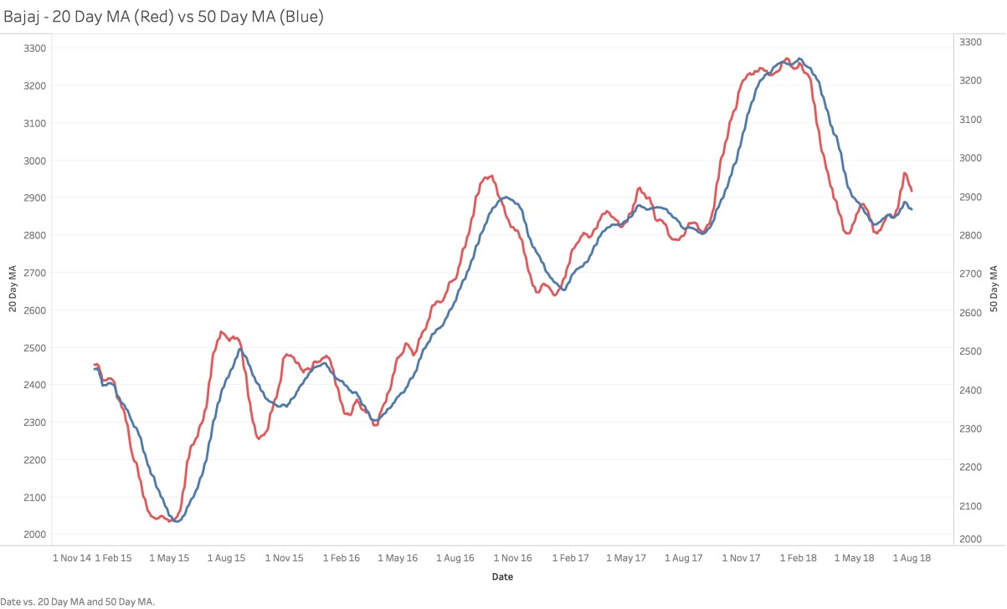

In order to BUY or SELL the stock, the Moving Average concept is applied. Moving average use the past data to smoothen the price curve. When the shorter-term moving average crosses above the longer-term moving average, it is a signal to BUY. But, when the shorter term moving average crosses below the longer term moving average, it is a signal to SELL.

An interesting fact to note is that no BUY/SELL has happened on Weekends (Sat/Sun). And most transactions have happened during start of the week and minimum transactions have happened during end of the week and No transactions happened on weekends.

|  |  |
| --- | --- |
| **Day** | **BUY/SELL** |
| **Monday** | 7 |
| **Friday** | 2 |
| **Thursday** | 7 |
| **Wednesday** | 2 |
| **Tuesday** | 5 |